

Clinical waste must be packaged, handled and collected under controlled conditions and cannot be disposed of with other wastes. There are legally enforced regulations covering every step in the clinical waste management process.

Defined in the Controlled Waste Regulations 2012, clinical waste is waste from a healthcare activity (including veterinary healthcare) that:
(a) contains viable micro-organisms or their toxins which are known or reliably believed to cause disease in humans or other living organisms,
(b) contains or is contaminated with a medicine that contains a biologically active pharmaceutical agent, or
(c) is a sharp, or a body fluid or other biological material (including human and animal tissue) containing or contaminated with a dangerous substance, and waste of a similar nature from a non-healthcare activity.
Clinical waste must be ‘rendered safe’ to remove the risks that it poses.
ATCM office has contacted several clinical waste management companies on behalf of our members. After some comparisons of their services and prices, we recommend here below 2 companies to our members:

Greenwood Waste Management Ltd
Unit 1
47a Scotts Road
Southall
Middlesex UB2 5DD
Tel: 020 8847 2444
Email: greenwoodwaste@yahoo.co.uk
Contact person: Ben
Service Type: one off collection by calling, no contract needed.
Areas covered:
1.Most areas south down from Manchester and Leeds (including Manchester and Leeds)
2.May go a little further north, but not much, please contact for details
Cost:
- £6.00 per 5 litre box
- Minimum £20.00 charge applied
- £1.50 for a new 5 litre box

C.L.D. Hygiene Services Limited
170 Brooker Road
Waltham Abbey
Essex EN9 1JH
Tel: 01992 702 300
Email: contact@cld-services.co.uk
Contact person: ask any staff of hygiene
Service Type: Do not require or issue any form of contract, but issue waste transfer notes to all clients annually. You need to acknowledge the terms and conditions if you accept their quotation.

Terms and Conditions:
Terms
Invoices are rendered annually in advance and are payable within 30 days. Cheques made payable to CLD Services Ltd.
Prices are fully inclusive of all plant, labour and materials, exclusive of V.A.T.
Conditions
All accounts agreed must be accepted in writing and services are subject to a 1 month agreement and cancellation notice period.
Services cancelled within 3 months of start date:
Charged for all completed services – plus 2 months charge
Services cancelled after 3 months of start date and before 12 months:
Charged for all completed services – plus 1 months charge
Services cancelled after 12 months of start date:
No cancellation fee

Emergency call out within 48hrs Mon-Fri (when service has been completed and is not yet due)
£35.00

Areas covered:
1.Most areas North up to Birmingham
2.Please refer to the map below for details
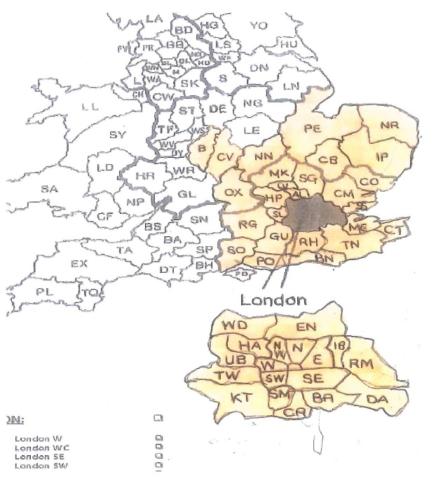
Cost for 5 litre box collection:
No. | ITEM/SERVICE DESCRIPTION | SERVICE  INTERVAL | ITEM COST | ANNUAL  COST
1x | 5ltr sharps disposal unit | Monthly / 12 visits | £ 150.00  per unit | £ 150.00  Per year
1x | 5ltr sharps disposal unit | Bi-monthly / 6 visits | £ 75.00  Per unit | £ 75.00  Per year
1x | 5ltr sharps disposal unit | Quarterly / 4 visits | £ 50.00  Per unit | £ 50.00  Per year
1x | 5ltr sharps disposal unit | 6 monthly / 2 visits | £ 25.00  Per unit | £ 25.00  Per year
ANNUAL DUTY OF CARE – FREE OF CHARGE

